MarketStreet Distribution Action Research

IST8101

Nicholas A. Bumgarner

Table of Contents
List of Tables and Figures....................................................................................................3
MarketStreet Distribution Overview....................................................................................4

Methodology........................................................................................................................7

Literature Review...............................................................................................................10

Testing...........................................................................................................................12

User Testing..................................................................................................................14

Responsive Design........................................................................................................15
Documentation .............................................................................................................17

Marketing......................................................................................................................17

Action Research Proposal .................................................................................................20

Defining Testing Criteria ..................................................................................................23

Testing Phase ....................................................................................................................24

First Code Sprint................................................................................................................33

Update MarketStreet Distribution......................................................................................40

Testing Automation..............................................................................................................

References............................................................................................................................

Appendix A..........................................................................................................................

List of Tables and Figures

Figure 1-1 The V Model of Testing...................................................................................12
Figure 1-2 Testing Vs. Cost Graph....................................................................................14
Figure 1-3 Iteration Diagram 1..........................................................................................22
Figure 1-4 Iteration Diagram 2..........................................................................................33

Inclind, Inc. is a small web development company located in Georgetown, Delaware. The company specializes in developing websites with an open source web development platform called Drupal. Drupal is a system which is built, supported and maintained by a large development community and is free for all to use. Drupal is a powerful platform for customization and allows for comprehensive management by nontechnical users. Anybody has the access to build, develop and upload any number of custom built modules, themes, distributions or patches. Being heavily involved and invested in the Drupal community, Inclind, Inc. planned to develop and distribute an application called MarketStreet.
MarketStreet is a distribution which is going to be made available to everybody on Drupal. The distribution is a powerful system which includes a customer relationship management system, a membership system for customers, an e-commerce capability which allows people to sell products as well as marketing and advertising capabilities. MarketStreet is intended for use by municipalities and tourism offices. The system supports self promotion for tourism and serves as an outlet for businesses to communicate, advertise and gain exposure via the system.
Inclind benefits from the system in various ways. The system alone serves as a platform for the company to build and develop complex websites for those municipalities and offices who need customized websites. By having a pre-built system in place, Inclind can quickly turn around complex websites, increasing efficiency and profitability. The company also gains great credibility by having developed MarketStreet for potential clients and for the general public within the Drupal community.
The MarketStreet system is comprised of both open source systems as well as customized modules. The production team which built the system includes a director of operations, two front-end developers, two web programmers, a project manager, and a training and support specialist. The team accomplished the initial build of the system by utilizing various resources, both internal and external. The majority of the application was customized using third party applications. For example, a responsive framework called Foundation, by Zurb, was used to ensure the website would be responsive to various types of media devices. Another system, called RedHen, was used to build a customized Organization feature in the system. All components included that currently exist on the site have been used to create a fully functional system which is to run on Drupal 7.
Inclind developed this system and has already used it to build some websites. The websites which have been built serve for smaller local organizations and utilize the first functional version of the MarketStreet system. Almost immediately after using the system, several issues were found and addressed. The MarketStreet system is not currently available on Drupal.org, where it would be made available to both the general public and the Drupal community. At this point, the system is functional but far from bullet proof.
The system has been extensively tested by the production team at Inclind, but has not yet been tested by those who are going to adopt and use the system. Once the system goes public, there will be countless number of people developing with the distribution, and there are bound to be issues found within the system. This, and the expectations of the system may change as clients are given websites to use, or the needs of future clients require further customization of the system.
The MarketStreet application needs to be tested and documented before making its debut on Drupal.org. Once made available to the masses, the system will need to be supported, and any bugs reported by the community will need to be resolved. The experience of using the system will have to be maintained and improved when possible and third party software which is used in the system will require updating regularly.
In addition to creating a distribution available on Drupal.org, Inclind intends on building a website to market MarketStreet. The website will serve as a funnel to Inclind's website, and hopefully convert interested people into future clients. The design and build of the new website has yet to begin. This is all part of the scope of the MarketStreet project, both the distribution itself, and the marketing and presentation of the system.
As Inclind begins to use this distribution to build more and more websites of various size and scope, there will surely be changes and requests to the already prepacked application. There may be some customized features later added to the system, which only require the request of a paying and willing client. As time continues, Inclind will find ways to improve the system. These improvements may come in the way of additional and new features or may be security patches, bug fixes or general code improvements.
A huge effort has gone into this distribution already, but in order for MarketStreet to truly shine, it will still need to go through a lot of testing, upgrading and revisions. The system must be bullet proof, constantly updated. Support must be made by the team for those in the Drupal community, and solid documentation needs to be written for the system. The application must be marketed appropriately, and the project needs to be useful for those using it, and serve as a building tool for Inclind.
By carefully documenting and researching the processes and procedures of developing this system, one should hope to gain a great understanding of what it takes to build such an in depth system. In learning this, one would understand the strengths and weaknesses of the development process for the company, and should find room for improvements. Development timelines and expectations will become clear, and the strengths and weaknesses of the team will become apparent.

Methodology
The scholarly approach to learning through experience is formally known as Action Research. Unlike traditional research, where one simply makes observations and comes to speculation, action research requires the researcher to become involved in the matter at hand. In using action research, the investigator is forced to recognize issues in the studied process, and learn how to make improvements (Tomal, 2010). Tomal further explains that action research is used in many environments and is useful in gaining valuable insight on any task or process. The action research process is very involved and is time consuming, but the thoroughness of the process is unequaled .
Action research was made popular in the 1970's and was adopted by business management in an effort to increase business efficiency (Tomal, 2010). The action research process is not only very involved and informative, but truly forces one to view processes in a way which they may not have normally. Due to the investigator's involvement in the processes, one can truly find what it means to complete those processes, and hopefully find ways to improve the work flow and inform others of those improvements (Somekh, 2005).
One characteristic of action research that is always true is that the person who is in charge of the action research project is a primary beneficiary of that project. Often times the research is initiated by one's desire to analyze and improve some process or system that the user is directly involved in (Farmer, Lesley & Cook, 2011).
The process begins by defining a known problem. The researcher will generally gain a general understanding of the issue by researching possible problems and known issues regarding the process at hand. The researcher will then draw a hypothesis on the causes of the initial problem. At this point, the researcher will test the hypothesis and reflect on the results (Farmer, Lesley & Cook, 2011). Farmer, et al also find that since the results are generally different than the expected outcomes, this process tends to repeat itself, in a pattern of hypothesis, testing, reflecting and improving.
The very basis of action research lies in the action, or participation part of the research. The investigator undergoes a cyclical process in which that person will plan, take action, judge and reflect upon a particular facet of the process being analyzed (Coghlan & Brannick, 2009). Coghlan & Brannick continue by explaining that the process continues with each aspect of the research project; this is where the researcher becomes involved in the project and where the experience takes place. Researchers are encouraged to create new hypothesis based on an outcome, and investigate it further.
Instead of simply making observations of others, the investigator is working and directly influencing those who are being studied. The investigator becomes a partner in the project, and acts as an interventionist in various points of of the investigation. Possibly the most important aspect of the action research process is that the researcher is in fact researching and analyzing their own actions and decisions, which are derived by their own decisions and influence from the others involved in the task being researched (McNiff & Whitehead, 2011).
Many times the value of the action research comes in unexpected forms. Considering the primary investigator in an action research project is always invested in the subject, it is no surprise that those investigators often learn surprising truths in their findings. The investigator in an action research project is asking questions and learning how things are accomplished. In many scenarios, the investigator usually would look at things in a theoretical manner, assuming causalities and outcomes. Once the researchers are placed in a position of actual practice and application, those researchers will see the differences between the theoretical assumptions about the process, and the possible hidden realities which exist (Winter & Munn-Giddings, 2002).
The uniqueness of action research lies in the process itself. If one was to simply study the events of a group without intervening in the process, that person will perceive and understand those processes in a much different manner than that of an action researcher. The action researcher will influence the outcome of the process, will learn from the influence and will help those involved in that process. The researcher is not simply watching what is going on, but is in the middle of it, asking questions and making suggestions (McNiff & Whitehead, 2011).
Due to the nature of the work completed by Inclind, Inc., it is only fitting that an action research project is applied to that settings. The various processes involved in completing and polishing the MarketStreet application could be closely analyzed to find various strengths, weaknesses and inefficiencies in the development process in the company. The action research methodology would require the investigator to truly understand the processes involved in the various stages of production and may reveal unknown issues within that development process. Since the company is constantly developing systems, this kind of research would be useful and applicable to all future endeavors brought on by Inclind, making the company more efficient, and spread knowledge from within.

Literature Review

Prior to commencing an action research project on the MarketStreet distribution, it will be imperative for the investigator to have a solid background on the aspects of the project that they plan on researching. Considering the remaining steps left in finalizing and distributing the MarketStreet software, the bulk of the research will be placed on software testing, user testing, documentation, marketing and implementation. In order to create an acceptable and realistic standard for which to base the company's performance on, the investigator will first need to have a solid background in how those processes work.
MarketStreet has been developed and has undergone a minimal amount of basic testing. Before making the software available to the public, Inclind needs to ensure the system is absolutely bullet proof. Not only will this help eliminate future support tickets, but it will speak to the quality and thoroughness of the work that Inclind produces. The extra time it may take to test the system through and through, while daunting at first, will result in the most confident, pride filled launch imaginable. The process of testing a system is indeed a tedious task, but it must be done. Once the system is released and countless numbers of people begin testing the system, it will not take any time at all for the users to find any bugs or shortcomings of the development team.
Depending on the standards, testing can be as detailed a process as anybody might imagine. No matter the level of testing involved, the first task will almost always be to define a plan. Before testing can being, there needs to be a plan that is based on where the project is currently, and where it is expected to be by completion. Once the plan is set and there is a specific goal defined, execution can begin. After the execution, the actual testing part of the process can be done. This will include the actual involvement of people using the system and looking for any behaviors in the system which are outside of the goal. In essence, the users look for any abnormalities, report it, and leave it for the development team to correct.

Testing
Various recommendations have been made about testing, including what to do and what no to do during the stages of development. One piece of advice explains that during the stages of testing, one should first look for larger bugs rather than smaller bugs. There is a fear that by correcting smaller, less important bugs first, this may create waste. The smaller more detailed bugs, if dealt with too early on, may be a wasted effort, or may require additional attention later in the project while it may not have needed it at all. In instances, a minor bug may become a non-issue depending on any larger issues. For instance, the team should not be concerned with fixing multiple small bugs in a section which becomes removed from the software, as an example (Black, 2011).
The idea of testing from a top down approach is nothing new. There is a testing model, which is similar to the waterfall systems development life cycle, called the “V Model”. This model suggests that testing should be done on a larger scale, and through various iterations, become more granular and detail oriented. Identifying the larger bugs first will help to eliminate smaller, unnecessary fixes later in the project. Figure 1-1 properly illustrates the cyclical nature of the “V” Model (Black, 2011).

Black, R. (2007). Pragmatic software testing: Becoming an effective and efficient test professional. Indianapolis, IN: Wiley Publishing, Inc.
Figure 1-1 The V Model of Testing
The testing discussed to this point has been strictly based on the technical aspects of the project, including functionality and bug testing. User testing is another important aspect to ensuring a satisfying system is in place. With user testing, one would be looking more into the experience that the user has. Often times, the development team will have a clear idea of how the system works, especially considering they have vested countless hours of time developing it. To make the system truly great, there needs to be user testing. User testing will allow the actual users, those not developing the system, a chance to use the system and provide feedback. If a system is not intuitive enough, and is confusing for the target audience, there needs to be revisions to the design. The best software will not require the user's to think very much, and should be very natural to use. There may be issues in the user experience that will not be found until somebody has had a chance to review the software (Rubin & Chisnell, 2011).
User Testing
It will be important to consider the different users which will be utilizing this application. The system which Inclind has developed will allow people to not only visit a custom built website, but people will be in control of monitoring and controlling the website from the back end of the system. For the MarketStreet application to be successful, it must be simple enough to use that people of different ages and technical backgrounds will be able to use it. If several younger, technically inclined users can manage the system without difficulty this is a great start. However, if the administrator’s platform is difficult or too confusing for users of a different age, the system is not up to the standards it should be. This same concept should be applied to the front end of the system as well. Since MarketStreet will allow for membership sign-ups and content editing capabilities for the general public, it is important that the front end of the site is intuitive for everybody. One may argue that the administrative side of site should be manned by somebody of a certain competency level, but the front end needs to be easy for anybody to use (Myers, Sandler & Badgett, 2011).
Inclind will do well to fully test the MarketStreet application before releasing it. User testing and functionality testing will be required, and if orchestrated properly will be of a great benefit to the company. The one thing that Inclind will need to be weary of is over testing. Testing is a great way to ensure the system will run properly and that it is widely accepted by the users, but there is a limit to testing. Flawless code is never a bad thing, but there has to be a limit if the company building it wants to stay in business. Under testing will result in a faulty system which does not offer a pleasurable experience, and over testing will cost too much to the company. There is some point in time where the benefits of testing outweigh the cost to the company. As figure 1-2 shows, there is a direct correlation between the number of defects, and the number of tests. Another way to view this, is there is a correlation between cost to the company, and the usability of the system. There will come a time where the bugs left to fix are too minor to test for, and finding that balance is crucial (Koirala Sheikh, 2009).
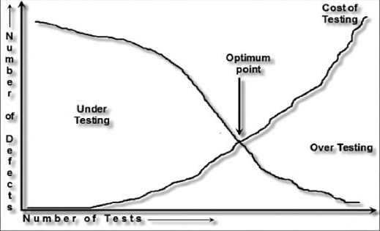Figure 1: 2 After a certain amount of test, the cost of testing outweighs the benefits of testing.
Koirala, S., & Sheikh, S. (2009). Software testing. (Revised ed.). Sudbury, MA: Infinity Science Press, LLC.
Responsive Design
One of the features of the MarketStreet application is that it makes use of responsive design. Responsive design is a method of building a website in which the website will behave differently depending on how the user is viewing it. For example, if you view a website on a mobile phone, some content will be removed, fonts will become smaller and images will shrink allowing the user to have the best possible experience while viewing the website on their device. This is true for different sized monitors as well as tablet devices such as iPads or Nexus'. Testing will need to be done for various devices as well as operating systems. The Apple iPhone uses a different browser than an Android phone will, and it is important that appropriate testing be done across all devices, and all browsers. Considering the amount of browsers and devices available, it would be difficult to fully test every device and every browser, which create an exponentially long list of conditions to test in. Each device has various versions of its software, and the same goes for internet browsers. Inclind will need to find out which browsers and devices it will want to support, which may be done by looking at recorded statistics of popular browsers and devices (Fling, 2009).
There has been some debate as to how to present content to mobile users. In many instances, people will trim out the unnecessary content from a website to present to a person visiting their website form a mobile device. Due to the smaller screen of the user, it may provide for a better experience to remove any content which may be in the way of the user getting to what they need quickly. There has been some debate of this, largely due to the preference of various users being so different. It will be good for Inclind to determine if their users need a trimmed down version for their mobile users or if they should simply present all the same content of the site in a way that is easy for the user to understand (Girard).

Documentation
Once Inclind is confident that MarketStreet has had the optimal amount of testing, it will have to prepare the documentation for the distribution, hopefully before releasing it on Drupal.org. The documentation process will be fairly involved, and must describe how the system is installed, used and updated. There exists a set of recommendations on Drupal.org which suggest how the documentation is setup. While it is not required that documentation follows it's structure, Inclind will want to be compliant with Drupal.org standards. Drupal standards suggest making a clear guide, which can answer a user's questions, without going into too much detail. In essence, the documentation should be broken down into the smaller possible pieces, and is similar to the DITA standard of documentation (“Online documentation structure,” n.d.).
The documentation will need to contain all the necessary information so that users can answer any questions they may have, but the documentation should allow for this process to be quick. Rüping (2005) explains that, “...the usefulness of documentation decreases when more information is added, because finding relevant information becomes more and more difficult as the overall amount of documentation increases.” Rüping further explains that the overall quality of the documentation is more important than the quantity.
Marketing
One of the final steps in the process of delivering a fully functional, developed and documented system will be the marketing. MarketStreet is a system which is openly distributed to all, but in a local market, it's also a selling point for Inclind. Inclind will be able to target the many local tourist towns who will be able to benefit by utilizing Inclind and its system. The key to this success will be in the marketing. Marketing generally will often strategically promote some aspect of a product, either it's uniqueness or its advantages over competitors. Inclind will likely need to sell local municipalities on the benefits of using MarketStreet over the systems which are already in place. Inclind will be in good shape to sell this product to various clients, ensuring long term relationships which have been proven to be more profitable for companies and easier to maintain (Sandhusen, 2008).
A key to the success of the marketing of the application will depend on Inclind's content strategy. Content strategy has to do with the way that the content is written and created so that it can appeal to a specific target audience, which will be to anybody who may be a potential client or user of the software. The content which is specified for various people will also have to be tailored specifically to appeal to those people. It is important to bear in mind that some of those who will be visiting the site will be interested in having Inclind build them a customized website while others may just be considering it as the basis for their next in house project (Anderson, 2012).
Another great piece of advice is that the content which is being used in the site needs to be appealing. Anderson explains that content which is to the point and original is best suited for the web. In a world filled with boring content, it should be easy to directly appeal to a specific market. Thought provoking content is bound to help people pick up the phone or fill out a contact form before your run of the mill content (Anderson, 2012).
Inclind is going to build a website to promote the MarketStreet software, and it will be built using the MarketStreet software. One of the best ways for Inclind to demonstrate how the product works is to not only have used it, but to allow people to use the system openly.
A monumental moment for Inclind, Inc. will be when it fully releases the MarketStreet Distribution. Generally speaking, the implementation phase of a development life cycle would be to actually implement software and install it. MarketStreet will still go through this phase, but it will be in the way of making the distribution public, not necessarily using it for a specific project. In fact, Inclind has already began building small sites using the MarketStreet distribution, although it currently remains in a Beta state. (Lewis, 2008).
It is anticipated that after the initial release of the MarketStreet Distribution, there will be an initial round of support requests by those using it. Even if the features implemented work flawlessly, there are bound to be integration or feature requests for the system. There may be bugs which are found by users which Inclind never caught. It will be important for Inclind to address these issues as promptly as possible. Many people who are going to be looking to use the distribution from the Drupal.org side of things will look at open issues and will look to see how quickly those issues are resolved. Nobody wants to invest in faulty software before beginning a large project.
Once the distribution is released publicly, Inclind will have a chance to reflect on all of their hard work, and will see just how successful the entire process has been. All the testing, marketing, user research and documentation that the company does will all come down to that final moment, of the full launch into Drupal.org, and will be available to the masses. By researching the process of completing these goals, it is hopeful that Inclind can gain valuable insight into the process. The strengths and weaknesses of the company will be revealed, and it will be clear where the company needs to work in order to become more efficient.
Action Research Proposal
The first iteration in the action research project that is the MarketStreet Distribution will be to complete a thorough round of testing. It will be necessary to first hold a meeting with at least one developer, one front end developer, the owner of Inclind, and a project manager. The developers can discuss any anticipated issues with the system which would allow the testing criteria to be defined more accurately. The team will be able to collaborate and devise a plan on what should be tested for the MarketStreet application. The anticipated deliverable for this iteration should be a defined list for testing criteria against the system.
The second anticipated iteration of the research project will be to actually test the MarketStreet distribution. There should be at least two or three people from Inclind testing the system. Different people are likely to use the system in different ways, rendering a mix of results. The testers should test all of the previously defined criteria, and document any problems or bugs that they find.
The third iteration will be to take all the documented bugs from the testing, and create actionable objectives for the development team. The development team will at the time fix the bugs in the system. After all the bugs have been corrected, there should be a final test by the project manager to ensure that those bugs are no longer existent.
A fourth iteration should be to accommodate user testing. The user testing will involve content managers and system users primarily. These may include clients that Inclind have already moved to the beta version of MarketStreet or prospective users. The user testing will reveal any room for improvements in the setup of the system. The anticipated goal of this iteration is to create a list of actionable objectives which will improve the back end of the system and possibly front end aspects of the system if there are is any confusion in how to use the system.
A fifth iteration will be to document the system. Before documentation can be written, there must be a meeting with the project manager and the owner of Inclind to determine what should be documented. This will allow the project manager to determine what can be documented and who should be documenting it. There are features in the system which may require the insight of a developer, or simpler features which anybody could write.
A sixth iteration in the project will be to create the MarketStreet website. This will be a place for the system to promote itself, and will also give users a chance to test the system. The site needs to be designed, built and implemented. There will need to be a discussion between the marketing specialist, the project manager, the front end developer, the designer, the owner of Inclind and at least one developer. They will all collaborate to create a promotional website for this application.
One of the final iterations will be to implement the MarketStreet distribution on Drupal.org. The software will be uploaded and made available for use. This iteration will require the documentation on the system to be uploaded. The production team will need to become maintainers and supporters of the system on Drupal.org, which will allow them to work on any support tickets.
Once the last iteration has been complete, there will be an initial time where support of the distribution will be necessary. This is a never ending process, but for at least the first couple of weeks that MarketStreet exists on Drupal.org, there will be a lot of support issues to address. Bugs may be found and there will likely be questions to answer on the system as well. Figure 1-3 demonstrates the intended work flow of the action research project described. Any variations in the plan will be documented throughout the research project.

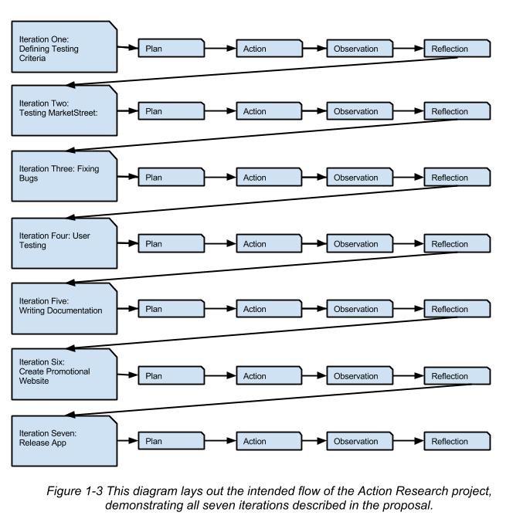

Defining Testing Criteria
Prior to commencing the action research project, the first iteration has already taken place. The basic plan for the first iteration was to hold a meeting with a programmer, the project manager, and owner of Inclind, Inc. to define a list of testing criteria. An unexpected meeting between between myself and the project manager took place first thing on May 29th, 2013. The project manager and I sat down and defined all of the major pieces of the system to be tested, including various content types and features found in MarketStreet, the various types of users which will be using the system, and a list of browsers and devices which the system must be tested against.
After the meeting, we had created an actionable list of testing criteria which we will follow to test the system in the new first real iteration of the research project. It was decided that the project manager and I will be the ones testing the system, and any bugs which we find we are going to document thoroughly in a document we created. After we test and document any issues or bugs in the system, we will then have an actionable list to deliver to the programmers and front end developers to initiative the fixing stage of the project.

The Testing Phase
Plan
To get the ball rolling on the MarketStreet action research project, the project manager and I will begin testing the system. Since we have a defined set of criteria, we will both already have a list to reference. The best way to go about testing the system will be to divide various parts of the system, browsers, users types and devices among the two of us.
Not only will we need to test the entire system in a multitude of browsers and devices, but there are essentially two parts of the system which we will need to test. The obvious part of testing will be for the everyday end user of the system, which are those who are visiting the websites being built MarketStreet, the front end of the system. When we test the front end of the system, we will need to look at how content is displayed and organized for the entire site. We will look to make sure all the content on the site is displayed properly and as anticipated.
The MarketStreet distribution features a responsive framework, so we will also have to check every part of the site on a desktop, on a mobile phone device, and tablet devices. All of this will need to be tested on both Macintosh and Microsoft operating systems, as well as Apple and Android devices. Inclind, Inc. tests for a specified list of internet browsers which are the most commonly used ones. We previously specified that we will be testing the system in Firefox, Safari, Google Chrome, and Internet Explorer versions 8 & 9. These browsers must be tested on both Macs and Windows computers.
We have decided that the best way to test the system will be to use it the same way as everybody else will. We will both create a fresh local installation of the MarketStreet system to use. This way we can note any issues or problems in the installation process, and truly start from the beginning. The installation will have some basic content associated with it when we install it, but part of the testing process will include testing the back end of the system.
Only a fraction of the people using the MarketStreet application will be actual administrators, so we have decided to focus the testing of the back end of the system purely on functionality. We will not be testing the back end of MarketStreet for any aesthetics at all. In order to properly test the front end of the site, we will create content in the back end of the site just as administrators will, allowing us to thoroughly test both areas of the site at the same time.
Testing the back end of the system will mean inserting various forms of content which will simulate how the site will actually be used. The various content types found within MarketStreet includes basic pages, events, classifieds, organizations, members, products, content products, simple ads and blog articles. As part of our testing, we will need to demonstrate that we can access, create and edit all of the above listed content types and features. MarketStreet is configured in a way to take a single piece of content and display it in many different places dynamically, and we will be testing to make sure each content type displays correctly in every instance that it exists.
Finally, we will have to test the site like a potential member will. MarketStreet is a system which allows for membership sign ups, and those members can contribute their own content to the site. The project manager and myself will both be testing the process of signing up for membership and go through the process of approval. Once we create fake approved members in our systems, we will test the capabilities that the user should have, such as purchasing content space, buying advertisements and editing business and profile information.
From here we will begin the testing process. I will begin by testing the system as an anonymous user, somebody who is just visiting the site. The project manager is going to begin by testing the site through the role of a member. I will be testing mostly on a Windows computer, and the project manager will begin by testing on a Mac. We have a Google Doc setup that we will both be using to record bugs which we find. We will pick up whatever testing task is left depending on what is available.

Action
The project manager and I both conducted testing as previously described. We began the process both by installing a fresh copy of the MarketStreet application and began by creating content. Testing in different operating systems, we went through our list of testing criteria. We tested thoroughly for the majority of a day.
As we found various problems or issues, we would take screen shots when applicable, and upload them to the testing documentation. In many instances, the bugs which were found were simple styling errors which will require minor code revision to fix. The screen shots that were uploaded are provided as a reference point for the production team for when they go to fix the bugs.
The project manager and I spoke with one another in regards to unknown variables about the project. There were several instances where we tested things without have a clear idea of what was expected of the system. The differences we found in the system which we were not sure of we notated in our testing document and highlighted as questions which we will need to speak to either a programmer or the owner of Inclind, Inc. about.
We tested the MarketStreet application on both Windows and Apple computers, covering most of the functionality that we had previously discussed. In all of the major browsers and devices we successfully tested the basic pages, event nodes, blog articles, organization feature, membership sign up process and content editing capabilities of all of these in the back end of the system.
After roughly 6 hours of testing and an extensive list of bugs found, the project manager called me into an unexpected meeting. During this meeting, we combed through the produced documentation and discussed all the bugs. Together we refined the document, clarifying bugs which were listed and removing duplicates. We organized the bugs into various types. The actual bugs which we found we highlighted with red text color, and any other functionality issues which required more discussion or clarification from a third party we colored green.

Observations
The first and most obvious observation to note is that the MarketStreet application has far more bugs in it than we previously imagined. We both filled up the testing documentation pages much quicker that we expected, and the testing process was moving much slower than we anticipated. We had hoped to finish testing the entire system within a single day, and at this point we are probably not even halfway done.
We found that many parts of the system did not function in a way that had made any sense at all. For example, a person who becomes a member does not have the capability of adding information about his/her organization. We found that this is a poor experience for the user and does not encourage content creation. A person who has just become a member should be allowed to create and update information regarding their businesses.
Another part of the system which we found to behave differently than expected was the membership process. When somebody registers to become a member, they must wait for a site administrator to manually approve their membership. This is extremely anti-climactic to a recently registered member.
Once membership is approved for somebody, we observed that the confirmation email that is sent to that person contains a link to reset their password. As I was testing this and had never previously seen it before, it appeared as a link which one must click to confirm their membership application process, which is common among websites.
As the project manager and I tested the system, we come up with various questions for one another, not knowing what was expected of the system. For example, neither of us knew if a member could or should be able to manage more than one organization. It would seem as though it should be possible, but was never discussed.
While testing the site there were also differences of opinion. There were things which I thought could use improvement that the project manager insisted was of an acceptable or comparable level. The main reason for this was a lack of clarification on the level of detail the MarketStreet application was expected to achieve in the first place.
After reviewing the testing documentation, we have a decent sized list of both questions and bugs (Appendix A). The project manager has requested that a review and code sprint be done before finishing the testing. The review will include several members of the staff and will hopefully allow the remaining testing to be done more smoothly.

Reflections
After the first iteration in this action research project, there are quite a lot things I have realized could use improvement in our processes. The testing process had too many unknown variables which slowed us down, and there was far more testing than two people should have taken on by themselves; at least in the expected time frame. It is likely that a little bit more time in preparation could have saved us a lot of time later on down the road.
Although not a direct part of this iteration, it would have been beneficial to have more control over the initial meeting. By not conversing with the project manager prior to the meeting, we did not have all of the people readily available who may have been able to provide valuable insight to the upcoming testing phase.
The testing seemed daunting especially once we had started. I feel as though it would have been beneficial for us to break down the testing process into even smaller pieces. Instead of trying to test the entire system in a single day, it would have been better to take the testing on one piece at a time. I believe this would allow us to concentrate on the testing criteria in more detail. Also, by having a few people focuses on smaller portions of the work, those tasks would seem more accomplish-able, and may have resulted in better results. It would also make things easier to do this way because if there was any questions regarding the expected functionality of the feature being tested, everybody involved would already know what was actually being discussed.
We tended to stay focused on separate parts of the system while testing, and whenever questions came up, the other person usually didn’t have a good understanding about what the question was. This required additional explanation and cost us time during the testing process. One way this could be avoided was to readily have a computer available to show the person, or to speak to somebody who was already familiar with the topic.
Finally it seemed as though the process of organizing all the found bugs took a long time. We had to filter through all of our notes which were separated by sections and make sure we did not record the same issues. There weren’t very many duplicated issues, but we wouldn’t have known if we didn’t discuss all the issue with one another. Since those bugs will later be converted into actionable items in our project management system, it probably wasn’t completely necessary for us to go through this process. The project manager could have easily weeded out the duplicates. Notes which aren't clear enough for others to understand need to be clear enough that nobody will require a custom explanation. Figure 1-4 demonstrates the iterations which remain at this point in the project.

First Code Sprint
Plan
At this point in the project, we have thoroughly tested about half of the MarketStreet system. Due to an unexpected large amount of bugs found in the system early, and to a lack of understanding all the expectations of the system’s functionality, we have decided to stop and review our progress.
The plan is to hold another meeting to discuss where the system stands, the next move in the project and to answer some questions we still have. The meeting should include myself, the project manager, at least one programmer and the owner of Inclind, Inc. This will be important since the owner will be able to explain what the system should or shouldn’t be able to do, and the programmers will be able to explain what is possible or not. The meeting will likely take place during the company’s morning meeting, and should be fairly brief.
It is expected that during the meeting, I will be assigned a number of tasks leftover from the previous round of testing. Since we already have at least fifty bugs that can be fixed, it is expected that I will be put to task to iron those kinks before testing the system further. The bugs which we already know we can fix and are simple aesthetic fixes I will be taking on over the course of a day to a day and a half.
Many of the bugs which I will be fixing will be related to various browsers, devices and operating systems. The changes will all be made locally on the MarketStreet project which was installed during the testing process. Once the changes have all been made and verified, they will be pushed to the repository which Inclind keeps.
After all the fixes have been implemented, it is expected that the project manager will complete a round of quality assurance. Each bug that is listed and marked as complete will be reviewed to ensure that it has been fixed. Any bugs which is found by the project manager that has not been thoroughly addressed will come back to me for a final revision.
This will be the final step in this iteration. We will begin with a meeting and there should be assignments to fix the bugs. It is possible that there will be functionality bugs which a programmer will be assigned to fix, but it is more likely that all the functionality and programmatic bugs will all be handled at once, sometime down the road. After all the initial bugs are fixed, we will then meet again to discuss the final round of testing and we can decide where to go from that point.

Action
There was a meeting held in which the project manager and myself voiced some of the concerns and questions regarding the MarketStreet system among other developers and programmers. The discussions covered a variety of topics which included determining the expected functionality of the system, discussion methods for fixing or adjusting various pieces of the system and general concerns about the system itself.
The resources and schedule that Inclind had during the time of this iteration forced the action to deviate from the original plan. It was expected that the main repository would have been updated and fixed after discussing the various bugs which were found, but we were put into a position where we actually had to start creating websites which had already been sold and were expected to use this MarketStreet distribution. The clients who had previously been sold to have their sites build on this system had already been waiting awhile for us to complete the distribution, and were eager to get their sites built.
Prior to being able to update the MarketStreet repository, we began developing two websites using the incomplete system. The idea was to at least get the sites started and built to a point to demonstrate to the clients to show that we were indeed working on something. The aesthetics of the site were accomplished quickly, and the clients were relatively pleased with the progress. During this time, the entire development team was constantly testing and fixing bugs which existed in both of these sites.
What would happen is anytime a functionality issue or adjustment was made, it was duplicated across both sites. After a couple of weeks of testing and fixing these two websites, it was necessary to begin building another couple of sites which required MarketStreet’s distribution. Since the first site that we built using the system had the majority of kinks ironed out of it, we used that first site as a baseline for the other website projects which were under way. In all, a total of five websites had been built using an incomplete version of MarketStreet.
As it is customary for Inclind to thoroughly test all websites, it was inevitable that we would catch even more bugs which had slipped past us on previous sites. For about a week, there was constant testing and development on not one single distribution repository, but five versions of the same code. This means if we found a bug in a single site, we would have to replicate those issues across all five websites. There was just a final round of testing and bug fixes, and after that Inclind has satisfied enough of its clients to set that work aside and get back to fixing the main repository.

Observations
During this iteration, a total of five websites were built using the MarketStreet distribution as it were after our initial testing sprint. Inclind is a company who must serve their clients, and our schedule does not allow us to only work on the MarketStreet distribution. In order to keep up with client demands, we had to begin implementing sites using a halfway tested, and not even debugged system.
A primary observation from this sprint is that the more we built these sites out the more we had realized how many bugs existed in the MarketStreet system. We had done an initial round of testing, but the testing was not thorough enough to find even major flaws that existed in the distribution. These were found by both internal testing of the sites that were being built as well as feedback from clients including their expectations and concerns.
During this time we were debugging and fixing basically the same code base which was replicated across several sites that were being built. While it would seem fairly straightforward to fix one site and replicate the changes, we found there were complications in this process. For example, code changes which were implemented and duplicated across all sites did not always completely resolve the known issues because configuration changes were also necessary to alleviate the problems.
During the changes of the site, it was not always the case that each developer was available to work on these MarketStreet projects. In some cases, developers with less understanding of the system were charged with fixing parts of the distribution which they didn’t fully understand. In some instances, it was found that a lack of information or understanding caused inefficiencies in the development work. Often times, somebody would have to be interrupted and brought into the project so they could explain how to fix a specific issue.
As tickets were created and bugs were corrected in the system, it was imperative for the changes and corrections to be implemented. This would ensure that if somebody else was needed to correct the same problem on a different site, the transfer of knowledge would be available to that person. The idea was that if the solution was well documented, it could easily be implemented by another person who had not previously worked on that issue.
During this code sprint, it was necessary to have developers verify the completed work of other developers. In a single day, it was common to have an upwards of fifty tickets completed and awaiting verification. It was too much for the project manager to do on his own, and so we would take the time to put each ticket through a quality assurance inspection. This was fairly successful, however after working on the same issues for a long period of time made it easy for unsatisfactory tickets to make their way through undetected. In many instances, a small oversight would allow this to happen.
Reflections
This entire iteration went completely awry. The entire point of testing and fixing the MarketStreet distribution thoroughly was to prevent having to fix bugs across multiple distributions. The fact of the matter is that we simply did not have the time to spend on this system. Even after the initial testing initiative, Inclind was simply too busy to work on this internal project. The work being done brought the company to a point with MarketStreet clients where we had to show them something.
It wasn’t that we didn’t want to work on the distribution, but we couldn’t justify delaying projects for an extra week or two to work on a project which we wouldn’t be immediately compensated for. I also believe that the MarketStreet bugs were originally perceived as being relatively minor. The list of bugs which were found were only a fraction of the issues which we actually addressed during the development of the five MarketStreet sites which we had to being.
At this point Inclind is caught up enough to actually put the time in to fix all the known issues in the system. The next iteration will still be to update the MarketStreet distribution with the knowledge we now have about the system from the previous development. Figure 1-5 shows the updated iteration plan. The green represents completed iterations, which include the testing iteration and the unanticipated site development iteration.

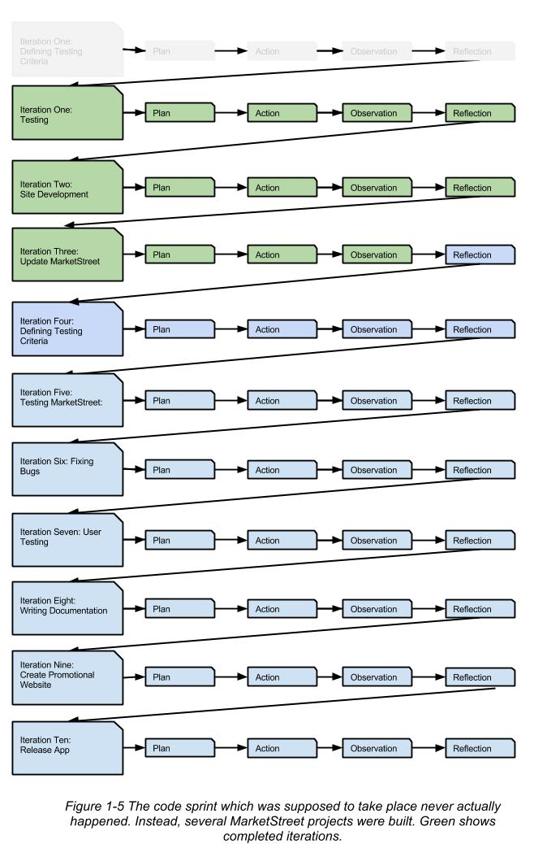
Update MarketStreet Distribution
Plan
Inclind is currently in a position where we can afford to spend a few days working on the MarketStreet distribution. The plan is to hold a company wide meeting to discuss a plan and organize the work which needs to be done to the distribution. During this meeting, all known issues will be mentioned, and the work can be divided up among the developers. It will be important that the appropriate tasks are assigned to the appropriate people.
The previous code sprint on the MarketStreet sites were mostly regarding functionality issues with the actual system. Many of the issues were related to the CRM and Memberships system of MarketStreet. The MarketStreet distribution has not thoroughly been tested for aesthetics across the various browsers and devices. Part of this iteration will include a thorough aesthetics test to ensure the distribution is responding to all the browsers and devices as it should.
Once the MarketStreet sprint has been discussed, a list of tasks will be assigned to everybody within the company. The code sprint will be accomplished by every member in the production staff, and it is expected to be completed within a couple of days. Since the majority of the bugs have been fixed numerous times across the previously developed sites, this effort should hopefully be a quick one.
As the development team updates code and tickets, the distribution will be updated. All code will be updated using the code versioning that Inclind adheres to. This will prevent issues when multiple people update the same code, and will help ensure nobody’s changes are overwritten.
Either during the code sprint or after, all of the tickets will have to be tested and verified for completion. It will be decided during the meeting who will be part of the QA process, and when it is expected to be finished. Once this round of testing and debugging is finished, it is expected that more MarketStreet projects will be initiated.
Action
The work was reviewed in a company wide meeting and the various remaining tasks to update the MarketStreet distribution were divided among the developers. All of the bugs and shortcomings of the system which needed to be addressed at this point were all items which had been completed at one point or another in previous projects. This helped make it easier to divide the tasks to the appropriate people who already had experience fixing those specific issues. In several cases, it was appropriate to copy code from previous projects to help mend the MarketStreet Distribution.
There were various changes made to the system which focused either on the aesthetics or the actual user interface. Those changes included making the layout of the site more consistent, making mobile friendly menus which were easier to use, and numerous tweaks to random elements. There were some style adjustments that were browser specific, and these changes implemented by myself and another developer only took a few hours to finish.
The largest task in this code sprint was executed by our lead developer. While we spent our time fixing the front end of the site which everybody can see, the lead developer spent several days fixing the inner workings of the MarketStreet system. During our development of several of other websites, we had found many parts of the system which either were too difficult to use or was lacking functionality which were fundamental.
The lead developer used one of the previous MarketStreet sites that had already been fixed as a baseline. Referencing one of the previous projects, the lead developer implemented code changes to almost every part of the system. The developer went through each section of the site, including the content management system, the custom management system for organizations and clients, the administrative feature of the site and many others. Among the changes were dozens of custom built rules, helping the system to perform various tasks such as deleting accounts, e-mailing site administrators, creating events or closing registrations. After finalizing these changes, we finally have a version of MarketStreet which is complete enough to move forward to a final round of testing and we can prepare to get a website ready for MarketStreet.
Observations
The majority of the work which was completed in this code sprint was completed by a single person. Generally when a Drupal website is built, the code is used and a site is built. All the site's customization and configuration changes are stored in the database. This is was gives each site its content, module configurations and settings. In order to deliver a highly customized website based simply on the installation of the site, we utilized a Drupal module called Features. In essence, the Features module will look for any changes made to the system, and will export all the configuration changes in code form, so when somebody installs another copy of the site, all the configuration changes will be made based on the Feature's exported settings.
The lead developer is the only person who has had any experience using Features, and was the one who suggested using it for the system. While Features is a great way of implementing the highly customized site into an exportable code base, the learning curve is somewhat steep here. This limited the amount of work that could be done on MarketStreet because the only person who could efficiently use the system was the lead developer. During the time of finishing these final changes to MarketStreet, this same developer was already needed on several other urgent projects. The limited availability of this single person delayed the project.
The changes that this person made on the project also creates a limited knowledge base throughout the development team. Since the bulk of the work could only be done by a single person, there were a lot of configuration changes made to the site that nobody else is aware of. This could potentially be problematic down the road, in the case of site maintenance or adjustment being needed and the person performing that task not understanding how a piece of that site is working.
Reflections
The complexity of the MarketStreet Distribution project can not be overstated. A heavy part of the project relies on custom programming, a skill that not everybody in the production staff has. Some tasks which seemed simple could often times end up being a more tedious or difficult than anticipated. This is largely due to the requirement of making all configuration changes exportable with Features. It may have been useful for somebody else on the production staff to have taken the time to have the lead developer teach them how to use this proficiently. This would have allowed somebody to complete a lot of work that was ready to be done on MarketStreet without having to wait on the lead developer to become available to complete this work.
At one point during the styling adjustments, I found some code which was implemented as a fix for the project's mobile menu. The issue was that the mobile menu was not displaying all of the links it contained. Where the menu may have had 9 links in it, you could only see the first five. Since MarketStreet is using Foundation, a system which we know works and can test, it would seem that we had built our system incorrectly. Instead of figuring out what was wrong with the our construction and correcting it to match the Foundation framework, we implemented a fix by hacking the javascript.
In the end, this solution did seem to be the appropriate one, but it was never discussed as a possible solution. It is generally bad practice to override any platform being used, and the amount of time invested to update the javascript may have been too much. If discussed prior to developing this solution, it may had been advised to simply adjust the system to accommodate the working version of the menu, based on what Foundation provides. While the implemented solution seemed to have been the easier of the two, neither the problem or solution was ever discussed in any detail. This is a problem in the development cycle which has since been addressed by the project manager.
At this point in the process, we have an updated version of MarketStreet, and now we must move towards a final testing movement. We must first define what should be tested, and then implement the testing itself. Figure 1-6 demonstrates the anticipated iterations to come, green representing completed iterations.

Testing Automation

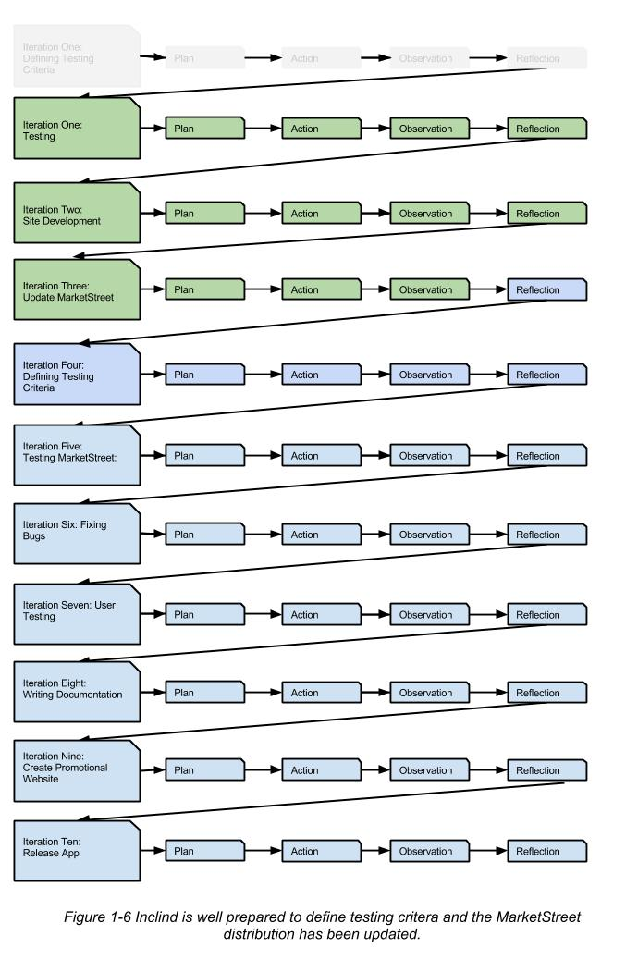

References
Anderson, C. (2012). The art of content marketing. Retrieved from http://www.smashingmagazine.com/2012/03/16/the-art-of-content-marketing/.

Black, R. (2007). Pragmatic software testing: Becoming an effective and efficient test professional. Indianapolis, IN: Wiley Publishing, Inc.

Coghlan, D., & Brannick, T. (2009). Doing action research in your own organization.
London: SAGE Publications Ltd.

Farmer, L. J., & Cook, D. (2011). Using qualitative methods in action research : How
librarians can get to the why of data. Chicago, IL: Association of College and
Research Libraries.

Fling, B. (2009). Mobile design and development: Practical concepts and techniques for creating mobile sites and web apps.

Girard, J. (2013). Building a better responsive website. Retrieved from http://mobile.smashingmagazine.com/2013/03/05/building-a-better-responsive- website/.

Koirala, S., & Sheikh, S. (2009). Software testing. (Revised ed.). Sudbury, MA: Infinity Science Press, LLC.

Lewis, J. (2008). SDLC 100 success secrets: Software development life cycle (SDLC) 100 most asked questions, SDLC methodologies, tools, process and business models.

McNiff, J., & Whitehead, J. (2011). All you need to know about action research. London: SAGE Publications Ltd.

Myers, G., Sandler, C., & Badgett, T. (2011). The art of software testing. (3 ed.). Hoboken, NJ: Word Association, Inc. Sebastopol, CA: O'Reilly Media, Inc.

"Online Documentation Structure." Drupal. Drupal.org, n.d. Web. 19 May 2013. Retrieved
from https://drupal.org/documentation-writers-guide

Perry, W. E. (2006). Effective methods for software testing: Includes complete guidelines, checklists, and template. Indianapolis, IN: Wiley Publishing, Inc.

Rubin, J., & Chisnell, D. (2011). Handbook of usability: How to plan, design, and conduct effective tests. Indianapolis, IN: Wiley Publishing, Inc.

Rüping, A. (2005). Agile documentation: A pattern guide to producing lightweight documents for software projects. Hoboken, NJ: John Wiley & Sons Ltd.

Sandhusen, R. (2008). Marketing. Hauppauge, NY: Barron's Educational Series, Inc.

Somekh, B. (2005). Action Research: A methodology for change and development.[New York]: McGraw-Hill Publishing

Tomal, D. (2010). Action research for educators. Lanham, Maryland: Rowman &
Littlefield Publishers.
Winter, R., & Munn-Giddings, C. (2002). A handbook for action research in health and
social care. London: Routledge.
Appendix A

MarketStreet Distribution Testing Initiative

Each individual testing task should be completed in
Safari, Chrome, Internet Explorer 8 & 9, Firefox, Android Mobile & Tablet, Apple iOS & Tablet

Blue - Non issue
Red - Issue
Green - Possible issue / Needs discussion

Testing an Anonymous Role

- Sign up for membership
- Note the user experience of signing up including success messages
- Note any success emails received when signing up
- Should be able to view any published organization
- View blogs on all browsers and devices
- View events on all browsers and devices
- View basic pages on all browsers and devices
- View classifieds on all browsers and devices
- Should be able to fill out basic contact form and receive confirmation
- Should be able to view and use the calendar of events pages
- Viewing the site on a mobile device should not degrade the experience

Testing an Anonymous Role with Commerce Enabled

- Anonymous users should not have access to view a content product
- Anonymous users should not be able to see any renewal product
- Anonymous users should be able to see membership products
- Anonymous users should be able to see physical products
- Anonymous users should be able to see event products [renewal information?]

Testing a Member Role

- A member should be able to edit profile information
- (Should) A member be able to add content with commerce disabled?
- A member should be able to edit and/or add content for multiple organizations

Testing a Member Role With Commerce

- A member should be able to purchase and create any purchasable content available
- A member should be able to edit purchased content [submitted for review]
- What happens if a membership is near expiration?

Testing Admin Role

Organizations

Blue - Non issue
Red - Issue
Green - Possible issue / Needs discussion

1. I should be able to add organizations
a. Successfully added a new organization
b. Edit screen needs organization
c. Could not mark an organization as featured (didn’t see an option)
d. Couldn’t see any information about anniversary date (Maybe not needed when organizations are not created through the store, need to discuss)
e.
2. I should be able to edit organizations once they are added
a. Can edit an organization successfully.
3. I should be able to manually archive or unarchive organizations
a. There is currently no way to complete this
b. What is the logic that makes a organization archived?
4. I should be able to add contacts
a. Successfully could add a contact
5. I should be able to connect contacts to organizations
a. Successfully connected a new contact to a Drupal user
b. Successfully connected a contact to an organization
6. I should be able to edit contacts
a. Could successfully edit a contact
7. I should be able to download reports for contact and organizations
a. Successfully downloaded contact report to csv (as admin)
b. Successfully downloaded Organization report to csv (as Admin)

Revisioning

- As an admin I should be able to easily see which content is pending revision approval from the dashboard
- There should be a clear UX to a member after submitting content for approval that it must be approved by an Admin before the content will post to the website.
- As an admin I should be able to see all revisions made to a node and approve each individual revision.
- I should see the dates of the revision

Organization Bug Notes:
1. Cannot mark an organization as featured by default as a Admin. I could do this as USER1
2. Layout of the Organization edit screen needs work (vertical tabs not ordered correctly)
3. Can only install example content as User 1, is this acceptable??
4. Errors after creating first organization as an admin http://awesomescreenshot.com/0771c0we9a
5. Created an organization, did a search, this was what appeared http://awesomescreenshot.com/0781c0xbd5 This should be a grid display. Also, this isn’t the proper layout. This was as an anonymous user. Not sure what happened to the Organization layout. DUPLICATE
6. Styling issue with the sidebar menu block http://awesomescreenshot.com/0781c13fd8
7. When editing/ adding an organization I cannot override the file upload with a name. just a config change to allow a description by default on that field. There should also be a MAX upload size by default of like 2MB

Noted Errors / Bugs

Bugs / Notes

- Anonymous User should not see “edit this page by clicking the edit tab,” default content on homepage. Plus this links to a page the user can not access. Default home page for anonymous users should either be or link to the user sign up page.
- After registering to be a member, there is a success message. The e-mail that is sent is somewhat misleading. It provides the user with a one-time login / password reset link, which is not really necessary. The rest of the e-mail looks good.
- Not sure if possible or not, but would be nice to include the site logo in the success e-mail.
- An registered member should be able to add an organization to the site. It may need approval, but this seems like a basic functionality that should exist. There needs to be a defined UX for setting up organizations when the store isn’t enabled. This could allow for automatic user/organization association as well, if possible, to reduce the manual process.
- As an anonymous user the business directory landing page should probably show some listings, possibly all listings with pager, and keep the business directory filtering block on top? Should be some UX text explaining to start searching or show some randow organizations.
- When viewing businesses starting with a letter, it seems like there is almost too much information being displayed. Should be more like a teaser list so people can quickly navigate through all the business listings. Basically the full node is showing on a search not the grid teaser.
  - Need to figure out why organizations go inactive after a few hours
  - Need a way for admins to manually make orgnaizations active or inactive
  - Organizations show only be in active if 1. The admin manually does it or 2. The renewal dates passes without the member renewing their subscription.
- Business teasers should not have the State: Active showing at all. This field should be hidden from all displays. Related to Biz Directory Grid Teaser View on search
- On the business node page, the logo needs to be reworked so it isn’t cropped off goofily. It needs to be scaled to fit, but not cropped.
- Seeing errors on the organization page.
- Breadcrumbs should show Home / Business Directory / Business Name (currently shows Home/ Business Name)
- On business node page, the phone number should not have a hover state [you can’t click it on desktop]
- When viewing the business directory page as anonymous user, I should not see an error message. Errors should be turned off for all non admins
- As an anonymous user, I should be able to view the business directory on mobile without the footer breaking. Styling issue, There is a screenshot for this issue.
- Error messages should have text-wrapping to prevent pages from breaking.
- The submit button on the mobile business directory search block should be at the bottom of the form so it is obvious that it controls all of the filters. Currently it only looks like it controls the search input box itself, when it really controls the input field and select boxes.
- When adding blog content, the category should not be required if there is not at least one default category included. Makes me upset when I have to go back and add a category and lose all the content I’ve already uploaded!
  - When creating an event node, the category should either not be required, or should contain a default category to choose from. Don’t let me add in 90% of the content before telling me I am required to choose a non-existing field! Reference #16 same issue
- Blog / Classifieds / Events categories page (grid view) grid block’s aren’t clickable, only the titles are.
- Weird spacing on blog body content on iPad displays. There is a screenshot for this issue
- Shopping cart says it is empty when it isn’t. Then you go add another product, go back to the cart and all of the previous items are there again.
- Do not give me the option of adding an event registration to my cart if there aren’t any tickets/seats left. Should be a notification that the event is sold out if at capacity
- When managing registration settings, Kevin’s e-mail address shouldn’t be the default “From Address”
- Looking at the event grid, doesn’t make sense how the fields display and say “Registration”. Basically the Grid view of events need to be adjusted about which information is being displayed. Also should this even be a grid view or a list view, the blogs are a list which usually follow the same layout as events
- iOS - basic page image has too much space around it. There is a screenshot . This is a minor issue.
- iOS - Event calendar See screenshot
- When clicking events, blogs or classifieds, the user is only presented with either search options or a calendar. Seems like we should have some kind of list available for people to view information without searching...?Need to further discuss the UX of these displays.
- Classified grid view - grid items have too much margin. Another minor styling issue
- Classified grid view should not display social icons.
- Sent an e-mail via contact form but never received it. Since we are enabling the contact form by default, the site admin needs to be in the email settings or there should be a warning to configure the contact webform further.
  - After filling out contact form, I shouldn’t get a link to go back to the contact form.. if the form went through I’m probably done with it. Link back to homepage? (ideally it would auto return to home page with success message)This relates the the previous issue
- Would be nice if site search results returned the content type for each result. IMprove search results UX
- When viewing content products, the breadcrumbs should include a link to the product category. There are a few places in the site there the breadcrumbs need work.
- Errors on install of Distro http://awesomescreenshot.com/0491c0nle6
- Error when adding new user http://awesomescreenshot.com/0cc1c0o588
- Dashboard should produce every time an admin logs in
- Can’t Access “Manage Organizations” or “Manage Contacts” by default as an Admin.
- Errors when going to “Manage Organizations” as Admin role. http://awesomescreenshot.com/0ce1c0ut87
- Errors when clicking “Add Organization” as admin role. http://awesomescreenshot.com/0de1c0v2d8
- Admin - Appearance section should show MarketStreet logo, not Zurb Foundation logo.
- Basic page vertical tabs: “page information” just has tags in it, should just go under the main category.
- Calendar Month display needs some adjustment
- Tags displays in a grid but the grid heights vary causing the layout to break. Either have a set height or not be in a grid display.
- . Membership products don’t show when store is enabled. Only the content category
- When clicking the content category in the store, the layout is no longer a grid but a list view.
- The “My content” and “My organizations” blocks needs to be assigned to /user by default.
- The “my Organization” block needs to have a function to edit their own organization. As a member logged in I was unable to edit my own organization listing.

